FIT3179 DATA VISUALISATION

Homework Assessment Week 4 - Visual Design

Shuangkun Fan

29849381

Tute 10_OnCampus

Tutor :Yidan Zhang

**Task1 Chart Junk**

Final dashboard:

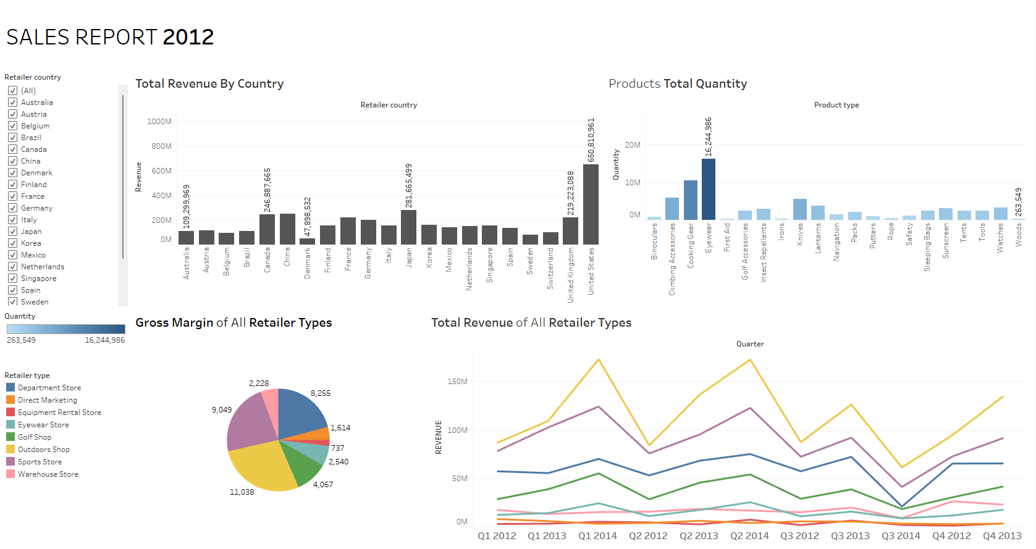

First, I removed the background image from this data visualization project because it doesn't encode any data and it's blurry. Next, I will talk about the identified chart junk and changes and modification accordingly for each graph.

* Products Total Quantity (Sheet 1)

In this chart I mainly removed two unnecessary ornamental elements they are the eyes and the wood picture, because the bar chart has indicated the products type of each item, then I found that they represent the highest and lowest value respectively, so I added the two mark labels showing the highest and lowest value on this bar chart. Secondly the background color and the grid behind this bar chart do not help one to identify the patterns and trends. So, I removed them as well. Next, I found that the line and the bar were visualizing the same kind of data, so it was redundant, and I removed the line as well.

* Gross Margin of All Retailer Types (Sheet 2)

In this pie chart, I mainly removed the black background color and the 3 annotations. This annotation mainly shows the retailer type and gross margin, but this pie chart already shows the value of gross margin for each retailer types, so it is redundant. Also, the legend shows which color represents which retailer type, so we don't need to label it in the pie chart anymore.

* Total Revenue by Country (Sheet 3)

For this chart, I changed the mark to bar because the different countries are already shown by the bar chart. Using a map to indicate the revenue of each country only looks like an unnecessary ornamental element. Secondly, I removed the column banding and the background color because they do not encode any data. I also removed six comments, instead I added mark labels to show the REVENUE of these countries, because it was clearer and those comments would overlay each other, which was not good for looking at the data.

* Total Revenue of All Retailer Types (Sheet 4)

I think this chart already has a relatively good data ink ratio, and I only removed the annotation for each type of store, because it uses a legend with the pie chart, which is already shown in this visualization project, and there is no need to annotate it here. Second, I removed the grid in the background.

**Task 2 - Colour, Layout and Typography**

In this data visualization, I mainly rearranged the position of the two figures and text. In accordance with most people's reading habits, I have placed the text at the top. The data is then marked in bold, and orange is used to highlight that this data visualization project is describing the state of Florida. This is also consistent with the colors used in the figure. And the two corresponding titles were added to both figures.

Final dashboard:

